DATE …………………………………… STUDENT NO……………………………...…………..…

EXAMINATION CENTRE ……………………………………………..………...…………..…………..

THE SHIPPING AND FORWADING AGENTS’ ASSOCIATION OF ZIMBABWE

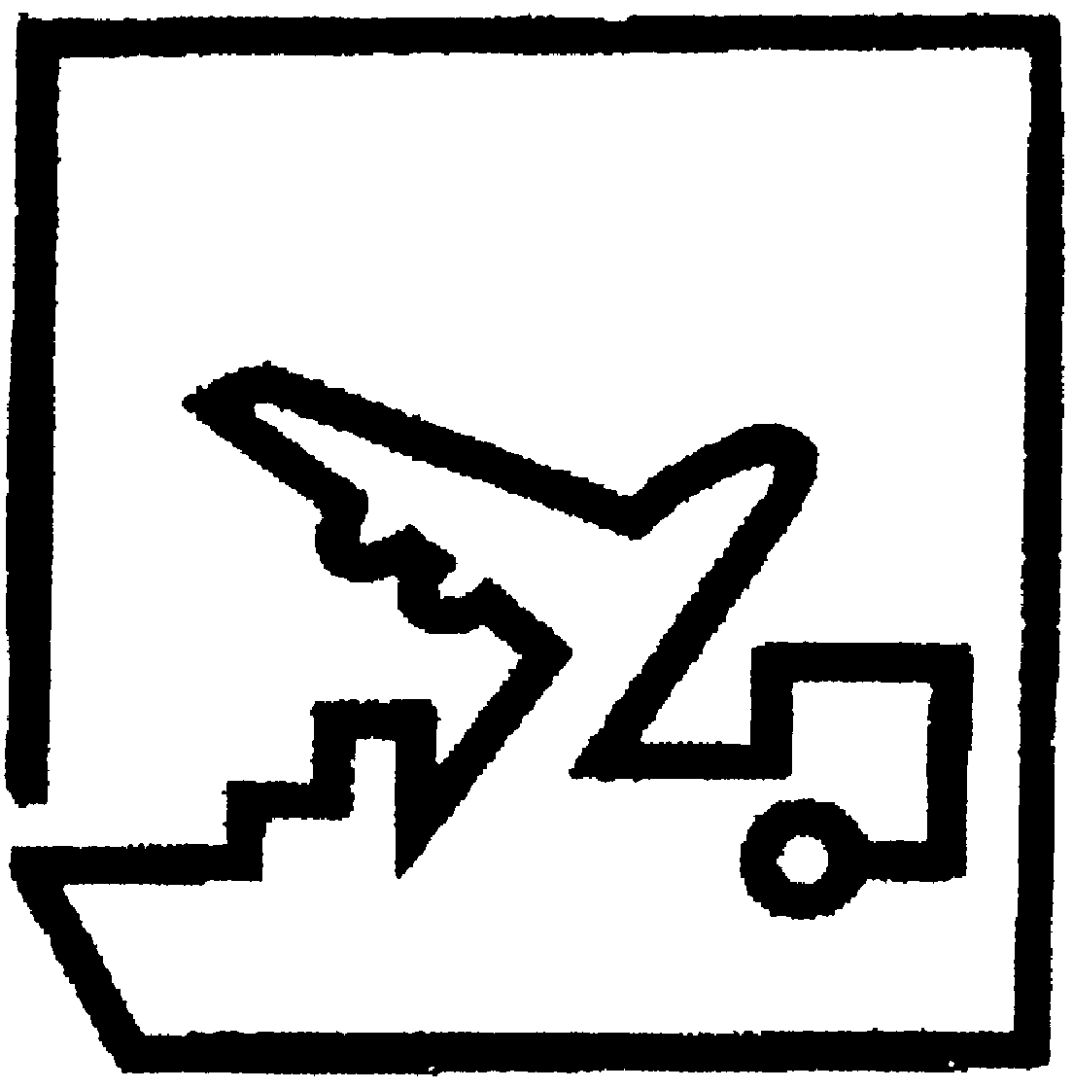

## FREIGHT FORWARDING PRACTICE DIPLOMA

**FINAL EXAMINATION**

**PAPER TWO**

# GENERAL PAPER – ESSAY QUESTION

**8 APRIL 2021**

**TIME ALLOCATION: (3 HOURS)**

**INSTRUCTIONS**

* Part A – Answer compulsory case study.
* Part B – Answer ANY THREE questions in this part.
* Remember to write your student number in the space provided on this page and on all other answer sheets you submit.
* Start each new question on a fresh answer sheet.
* This paper carries 75% of the final examination mark.

**FFP Diploma 2021 Final / P2**

PART A: CASE STUDY (COMPULSORY)

**QUESTION ONE**

Air Transport Case Study

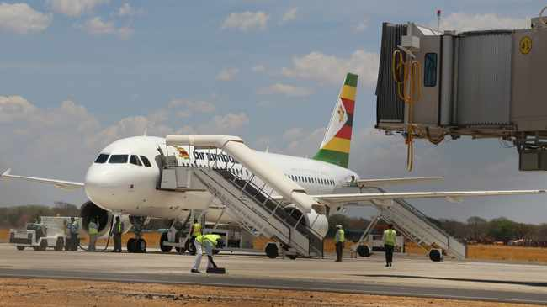

At exactly 08.30 GMT on the 15th of February, 2021. Air Zimbabwe Flight Um 364 arrived at Harare s Robert Mugabe International Airport. The Boeing 767 that had just touched down is one of the 2 that the Government of Zimbabwe had procured from Malaysia 2 years earlier. As the aircraft was being taxied to its hard stand under the guidance of a ground engineer one could only gaze at the beauty of this magnificent bird. From the vantage point where the author was sitting. It was beaming the beautiful colours of the Zimbabwean flag. Amid the noise one could still take a peep into the cockpit and the upper body of the captain was quite visible.

This aircraft was carrying precious cargo. It was the first ever Covid 19 vaccine from China. The Minister of Information Mrs Monica Mutsvangwa had made an announcement of a vaccine donation from China a few days back and this was the shipment now being delivered. The aircraft had left Chinas Beijing Airport 18 hours earlier and had stopped in Dubai en route for refueling. This type of equipment is designed for passengers and so could not carry the cargo on the upper deck but in the belly holds. Be that as it may the bellies have a capacity of 12 tons which was more than enough for this shipment.

**FFP Diploma 2021 Final / P2**

The upper deck was half full of passengers which was good for Air Zimbabwe as this was a chartered flight which means that the charterer in this case The Government of Zimbabwe had had paid for the full flight and any additional cargo or passengers would be a bit of money for jam for Air Zimbabwe. As soon as the aircraft came to a stop there was a rush with all sorts of ground equipment scurrying to service the aircraft. The loadmaster came down and made sure that the offloading of the cargo was in accordance with instructions. He had a cargo manifest which had instructions relating to what would be offloaded and onloaded onto the aircraft.

This load was what would be termed “Precious Cargo” and he made sure this was handled in the most professional manner. THIS SIDE UP, KEEP COOL AT-4 Degrees C were some of the instructions on the boxes. One of the dollies was returned back as it did not have a thermo blanket. This blanket would cover the vaccines so that there is no break in the cold chain. If there is a break then the vaccines will lose their efficacy and hence effectiveness. The Vice President and Minister of Health was watching proceedings with his aides from a distance and conferring with the executives from Air Zimbabwe and The Chinese Embassy. Just close by was the Permanent Secretary for health and some officials from The Medicines Control Authority of Zimbabwe.

After thanking the manager for the useful information we watched the magnificent 767 Bird of the Air taking off on yet another foray. The cargo manager could only say. “We can only make money if we are in the air and not on the ground so a quick turnaround is a must”. We could only marvel at the activities that had taken place in the last hour and wonder whether the good times would roll again for the national Airline Air Zimbabwe.

**Required: Using the case study above answer the following questions.**

1. What is a cold chain and how can it be administered from the place of acceptance to the place of delivery. (7 marks)

Cold chain is an industry that deals with temperature sensitive commodities.

Cold chains require constant monitoring on the temperature within the commodities and around them. Refrigerated facilities is advised from the place of origin (China), in transit and the country of destination (Zimbabwe). The temperature should not be the freezing but the manufacturer recommended temperature to maintain the quality of commodity. In transit the commodity would need to be kept at required temperatures, therefore the Load master ensures the Captain is made aware through the NOTOC. In between modes, the thermo blanket is used to keep the required temperature. The cartage vessel should be ideal for temperature sensitive commodity.

1. Why is cold chain important for this particular cargo? (2 marks)

Cold chains are commodities that require temperature throughout the entire supply chain(upstream to downstream). The drug is some form of dangerous goods that can only maintain its quality if stored in recommended temperatures. The manufacturer/ shipper instruction should be adhered to.

It is strategic commodity meant to fight covid pandemic and its time sensitive.

1. Identify at least 4 types of equipment used to handle the shipment explaining where they are used. (4 marks)

Any four from the following;

1. Loaders for offloading the consignment,

2. Straddle

3. Loading ramp

4. Tractor for pilotage and movement to AGS,

5. Dollies to place the containers on for delivery to road vessel,

6. Forklift for loading onto road vessel, Thermo blanket to cover the shipment as it is placed in detention area.

1. Identify and justify the suitable road vessel used to transport the shipment from the airport to the final destination. (2 marks)

A refrigerated as a temperature regulated truck the commodity would not go bad while in transit or Isotherm truck as a road truck that is like a flask/ cooler box that ensures the temperature would not rise significantly.

**FFP Diploma 2021 Final / P2**

1. If this was not a chartered aircraft there would be differences in the logistical design. Given the task of moving the cargo, what would you do as a freight forwarder? Give the total logistics solution from pick up to delivery. (6 marks)

The other alternative services that are available include the freighter, where the shipment is moved together with other commodities. This would require booking space with the airline before packaging of the shipment. The ULDs would then be made available to the airline agent who then supervises the loading and documentation. The other packing device could be the pallet which would be constructed guided by door height and the place it would be placed onboard the plane. The combination service would be determined by the class of the dangerous goods and only loaded if not restricted by the IATA DGR .

1. If your vessel was a “Çombi” how would you optimise on your revenue? (3 marks)

A combi is a plane that carries both passengers and cargo. To maximize the revenue one would allow the taking in of passengers, veering in mind the maximum takeoff weight of the plane. Consolidation also works here to make sure the space is cost effectively utilized.

1. What precautions were taken by the freight forwarder who was involved in the above shipment? (4 marks)

The class of goods. The adequate labeling and marking for easy handling. The appropriate documentation such as kemplar plate, MSDS /

1. Identify the category of the shipment. (1 mark)

Dangerous goods or Perishables accepted

1. Which four main documents are a must in moving such a shipment and why? (8 marks)

1. Commercial Invoice; detailing the quantity and unit price (on price inscription “Donation” often cited)

2. Travel Emergence Card; Shipper instruction on how the shipment should be handled, also showing risk levels and any subsidiary risks

3. Airway bill, detailing contents carried and can be used as a customs and accounting document

3. Packing List, showing the number of parcels and often used for tracing purposes.

4. Customs documents such as bill of entry import/export

1. Identify the type of service offered by Air Zimbabwe and two benefits that accrue from such. (3 marks)

The service offered by Air Zimbabwe is the charter service. This service ensures real expedition as there are no delays apart from those associated with refueling or mechanical nature. Secondly the service is more convenient to cargo that takes up close to full capacity of the plane.

**[TOTAL 40 MARKS]**

**FFP Diploma 2021 Final / P2**

PART B: ANSWER ANY THREE (3) QUESTIONS FROM THIS PART

**QUESTION TWO**

1. The purpose of INCOTERMS is to provide a set of international rules for the interpretation of the chief terms used in foreign trade contracts and thus they are used in conjunction with a sales agreement or other method of transacting the sale. Identify the 3 main factors taken into consideration when deciding which Incoterms to use. Use any INCOTERMs of your choice to justify your answer. **(6 marks)**

1. The company’s ability to bear the costs as indicated in the INCOTERM of choice. Which maybe the policy of the company to use the terms that are easier to understand their obligation.

2. Freight purchasing power, where the party with large quantities would benefit from lower shipping costs.

3. Legal and financial restrictions, where some import countries demand the freight and cost of insurance be paid to service providers in their country. Or,

4. Infrastructure in some countries are suspect and in such situations agreeing on delivery terms ensure goods are delivered on time in full. (choice determined by who bears the Costs, Risks and Obligation)

1. Whether it is for the better or worse, technology has touched and revolutionized almost all aspects of human life and business. Shipping and freight industry has also been touched by these technological developments under both mechanical ad digital categories ad these developments could determine future of shipping. One of the biggest technological revolutions or achievements in the history of world trade would be containerization which entered its 60th year I 2016. Citing examples, outline at least six ways containerization has revolutionized international trade **(12 marks)**

1. Gave birth to Consolidation / Groupage

2. Influenced the design of vessels

3. Created Real time 24/7 tracking and tracing of shipments

4. Increased quality and safety of commodities

5. Birth of Multimodal Transport

6. Development on port infrastructure

1. Using practical examples explain two benefits of ISO certification or FIATA accreditation to a Freight Forwarder. **(2 marks)**

**1.** ISO certification is a direct assurance to clients and customers of an organisation’s documented process that brings consistence in service offered.

**2.** It’s a marketing tool that attracts new customers particularly when dealing with markets they have never been. The FF can be used as a quality champion and realises high customer retention / attraction.

**[TOTAL 20 MARKS]**

**QUESTION THREE**

# A [Freight Forwarder](https://www.shippingandfreightresource.com/who-is-a-freight-forwarder/) is a multi-function agent/operator who undertakes to handle the movement of goods from point to point on behalf of the cargo owner. Achieving and maintaining profitability has been one of the serious problems faced by many freight forwarders and more so, in these trying times. Explain in detail any four cost saving strategies that a Freight Forwarder can employ to remain profitable in their day to day running of their business. Answer this question from an operational perspective. (12 marks)

1. Lean approach, doing more with less resources at double the time, where there is elimination of wastes.

2. Agile approach that is supported by the JIT as there is no stockpiling as whatever is done will have even initiated by the customer.

3. VAN that could be reciprocal or none, exclusive or Ad hoc. Having total visibility on shipments would reduce transit times as there is real time information that avert delays and abandonment of shipments

4. Value Engineering, when the parties brain storm on the feasibility of the project/shipment and held accountable for their contributions. (What is measured is manageable). Setting and agreeing on realism in the contract that curbs any demurrage / waiting costs

1. Identify any four transport Conventions explaining clearly the respective modes they deal with. **(8 marks)**

All convention sought to unify the rules pertaining to each mode of transport, setting the maximum liability on each.

CMR convention on international transportation of goods by road**.**

COTIF convention on international transportation of goods by rail.

WARSAW convention on international transportation of goods by air

Multimodal convention on international transportation of goods by all modes of transport

**[TOTAL 20 MARKS]**

**FFP Diploma 2021 Final / P2**

**QUESTION FOUR**

A giant container ship the length of four football pitches has become wedged across Egypt's Suez Canal, blocking one of the world's busiest trade routes. Dozens of vessels are stuck, waiting for rescue boats to free the 400m-long (1,312ft) ship, which was knocked off course by strong winds. Egypt has reopened the canal's older channel to divert some traffic until the grounded ship can move again. The blockage sent oil prices climbing on international markets. About 12% of global trade passes through the Suez Canal, which connects the Mediterranean to the Red Sea and provides the shortest sea link between Asia and Europe.

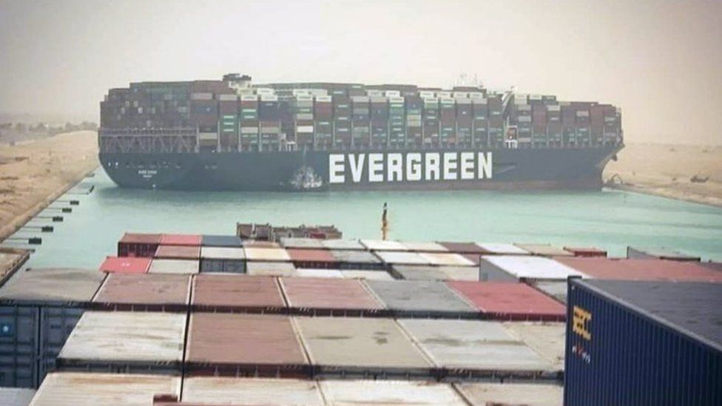

**a)**

1. What is a canal and identify at least three areas of importance that it provides? **(4 marks)**

A canal is a manmade water passage that passes through two main land masses.

It joins the two water bodies thereby reduce the transport costs.

It also channels the waters nearer the factories or industries.

1. Using the case above, why where oil prices affected by this blockage? **(3 marks)**

The jackknife situation has meant no vessel has been able to connect Indian Ocean from Mediterranean Sea. This calls for rerouting of vessels and take the Mediterranean, Atlantic and eventually Indian Ocean causing prolonged transit times thereby creating artificial fuel shortages. Principle of supply and demand come in effect where the prices shot up as the commodity became scarce.

1. Identify any 3 vessels that ply the Suez Canal. **(3marks)**

Oil Bulk Ore, Cellular, Ro/Ro vessels

1. Name any other two canals in sea transport. **(2 marks)**

Kiel Canal in Germany, Panama Canal in America (North & South)

1. Citing relevant practical examples, explain any four areas that ICT has improved the management of air transport services. **(8 marks)**

Black box that helps in after accident investigations, E documents AWB and the booking online , Communication of pilots and air traffic control, Air craft navigation (auto pilot) & metrological issues that help detect any issues that puts a craft in risks, Security issues where scanners and CCTVs are in use.

**[TOTAL 20 MARKS]**

**FFP Diploma 2021 Final / P2**

**QUESTION FIVE**

1. Fully explain the DG training requirements for the following.
2. The Shipper. **(3 marks)**

First being licensed in the class of DGs, Training on the manufacture (in depth knowledge), At least two permanent employees being holders of the DGs certificate and act as SHEQ personnel, Packing and packaging, Production of the MSDS and communicating this to all other parties.

1. The Operator or Transporter. **(3 marks)**

Licensed by competent authority to transport DGs, Driver awareness training, General training in dealing with DGs.

1. The Freight Forwarder. **(3 marks)**

Awareness training on the packaging of DGs, Handling of DGs and Appreciation of DGs

1. Explain four considerations that YOU, the freight forwarder, must identify before deciding on the transportation requirements for your client who will be exporting their product to an overseas market.

**(8 marks)**

The commodity type / nature (general, perishable, OOG and DGs cargo),

Distance /

Destination of delivery,

Company objectives/

Urgency of the shipment,

Liquidity of the customer,

INCOTERMs agreed on, etc

1. Define dangerous goods and explain why they are divided into different classes. **(3 marks)**

Substances or articles that pose risk/danger to people, environment and other commodities.

They are divided into class indicating their different characteristics and behaviour. Groups denote the level of danger they pose; very dangerous, average danger and least danger.

**[TOTAL 20 MARKS]**

**\*END OF PAPER\***